## horizontal line



Data Visualization Project

07.10.2021

**─**

Group 3

Kiara

Matt

Shannan

# Overview

Our objective for this project is to take an aviation dataset and review accidents over the last 20 years in order to tell a story through visualizations that users can explore themselves.

# Goals

1. Tell a story through data visualizations.
2. Provide users an interactive means to explore the data themselves.

# Requirements

1. Pull data for aviation accidents for the last 20 years
2. Remove null files from data
3. Remove columns Broad.phase.of.flight, Report.Status, Publication.Date
4. Split city and state into 2 columns
5. Add columns of minor and major injuries together
6. Create a Python flask
7. Include a JS library, HTML, Leaflet plugin
8. Filter columns by injury level
9. Create a filter that users can hover over to show more data.

# Inspiration

# 

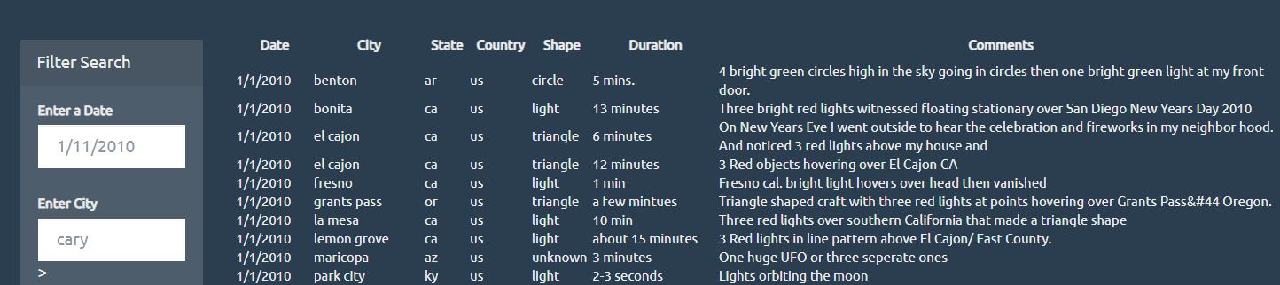

Our inspiration was drawn from previous activities we did during class pictured above. Our ideal final product will show points on a map of the locations of aviation accidents in the United States. We want to make this as interactive as possible for the user, so we will provide more data per datapoint if the user hovers over that specific point, as well as a filter, where the user can search for specific accidents, data frame, etc.

# 

# Final Sketch

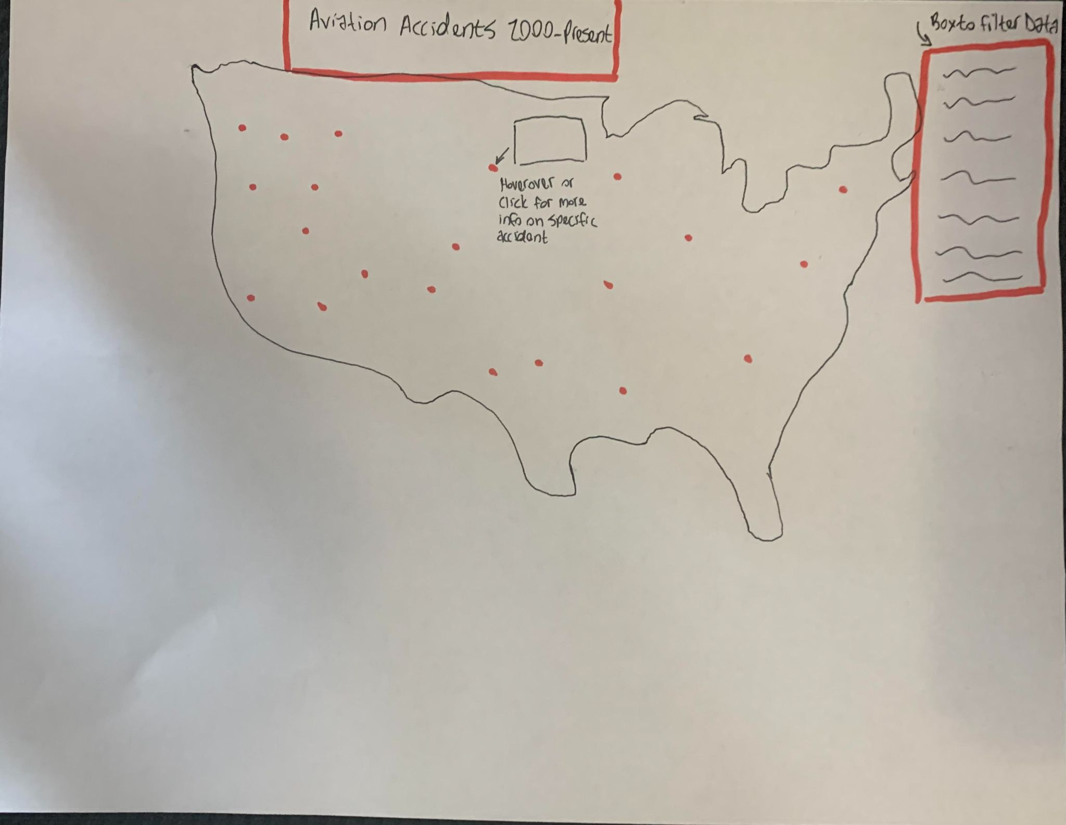

# Data Sources

## URL

<https://www.kaggle.com/khsamaha/aviation-accident-database-synopses>

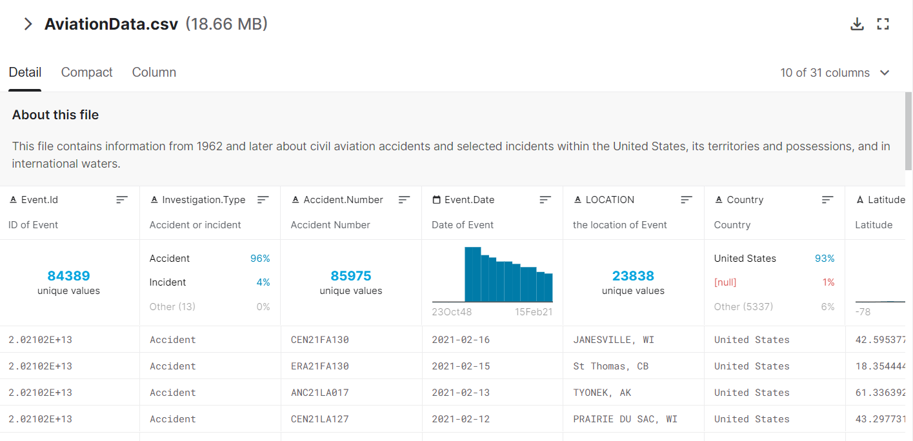

## Github Link

<https://github.com/mjweiper/data-visualization-project>